**Homework 3 Report**

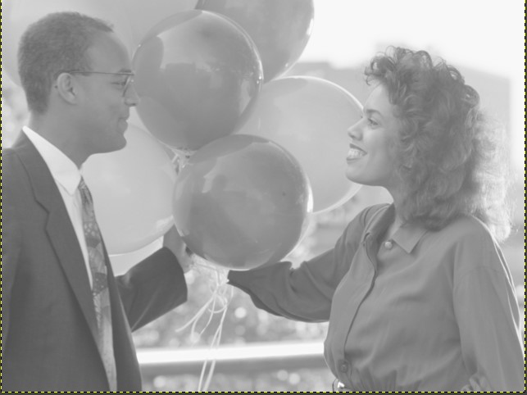**Input Images: Output Images:**

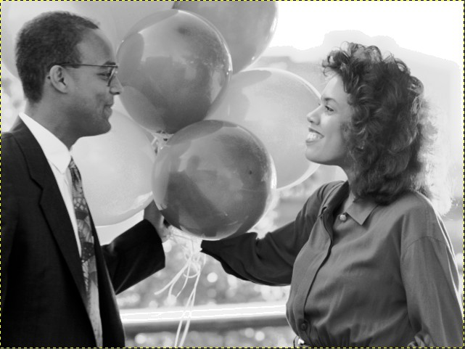

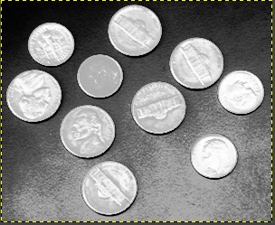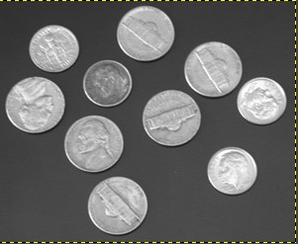

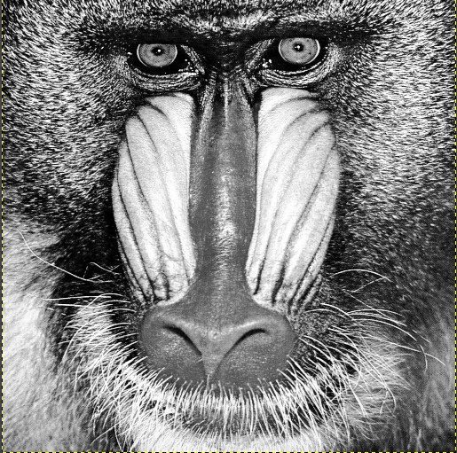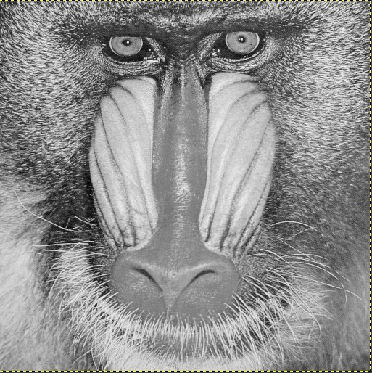

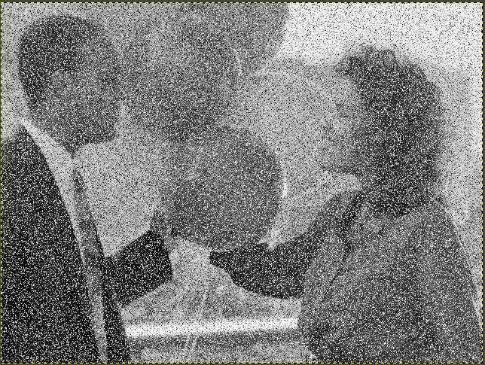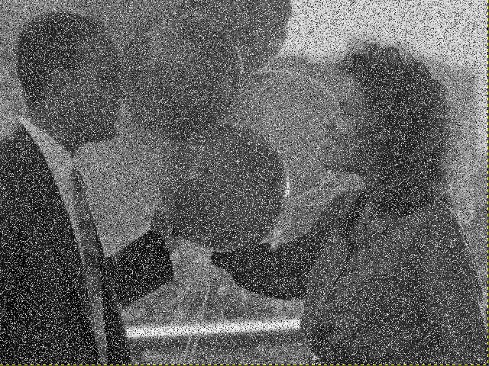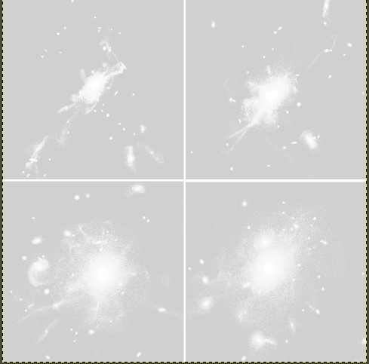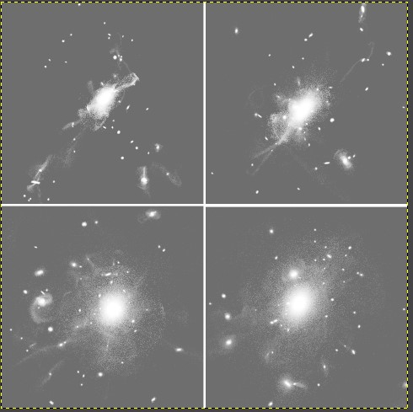

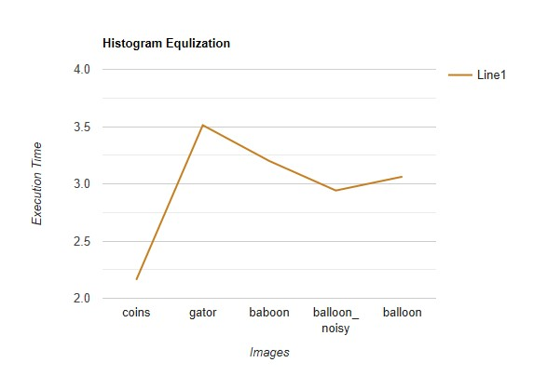

Used Colab in order to execute images. For the reading and writing pgm file, I used a library. Reading operation returns a float array. Code has 5 different host and device arrays. Defined for each operation(cdf, histogram, equalize, input and output). Hosts are used in order to check the values if they are correct or not.

So program reads the file and sets to a float array. Then, with malloc allocation host values are allocated. Also, for device, used cudaMalloc to allocate space.

Copies input image to device and calls kernel functions.

First calculates histogram of the image using atomicAdd function. Then CDF kernel is executed. CDF is implemented using reduction phase and post reduction phase algorithm in order to reduce the job on threads by reducing steps(shared array is used to calculate). This algorithms Works better than kogge stone algorithm. Then, scans the values and updates cdf values.

At last, histogram equlizer is called, and it calculates each value for each value. Then copies the device value of equalizer to the host variable and updates input variable with host of equlizer and assigns it to the output variable.

Finally, writes the values to the output file. Block size and Histogram sized are 256 bit. Scan size is set to 512 bit. If the block size increased by 1, then we should be increasing scan size by 2. In order to do 2 job in one cycle for thread blocks.

The algorithms are implemented from the book and wikipedia.